Morocco

## GNI per capita and development level

The data set shows the GNI per capita and development level of the country each year.

## # A tibble: 19 x 5  
## country iso3c date GNIperCapita devCategory   
## <chr> <chr> <dbl> <dbl> <chr>   
## 1 Morocco MAR 1996 1866. Lower Middle Income  
## 2 Morocco MAR 1998 1928. Lower Middle Income  
## 3 Morocco MAR 2000 1937. Lower Middle Income  
## 4 Morocco MAR 2002 2102. Lower Middle Income  
## 5 Morocco MAR 2003 2205. Lower Middle Income  
## 6 Morocco MAR 2004 2293. Lower Middle Income  
## 7 Morocco MAR 2005 2353. Lower Middle Income  
## 8 Morocco MAR 2006 2499. Lower Middle Income  
## 9 Morocco MAR 2007 2562. Lower Middle Income  
## 10 Morocco MAR 2008 2686. Lower Middle Income  
## 11 Morocco MAR 2009 2732. Lower Middle Income  
## 12 Morocco MAR 2010 2801. Lower Middle Income  
## 13 Morocco MAR 2011 2900. Lower Middle Income  
## 14 Morocco MAR 2012 2935. Lower Middle Income  
## 15 Morocco MAR 2013 3046. Lower Middle Income  
## 16 Morocco MAR 2014 3053. Lower Middle Income  
## 17 Morocco MAR 2015 3160. Lower Middle Income  
## 18 Morocco MAR 2016 3150. Lower Middle Income  
## 19 Morocco MAR 2017 3240. Lower Middle Income

## GDP growth and economic growth classification

The data set shows the GDP growth and the ecomic growth classification of the country each year.

## # A tibble: 19 x 5  
## country iso3c date GDPannualGrowthRate GDPgrowthCategory4  
## <chr> <chr> <dbl> <dbl> <fct>   
## 1 Morocco MAR 1996 12.4 fast growth   
## 2 Morocco MAR 1998 7.24 fast growth   
## 3 Morocco MAR 2000 1.91 slow growth   
## 4 Morocco MAR 2002 3.12 moderate growth   
## 5 Morocco MAR 2003 5.96 fast growth   
## 6 Morocco MAR 2004 4.80 moderate growth   
## 7 Morocco MAR 2005 3.29 moderate growth   
## 8 Morocco MAR 2006 7.57 fast growth   
## 9 Morocco MAR 2007 3.53 moderate growth   
## 10 Morocco MAR 2008 5.92 fast growth   
## 11 Morocco MAR 2009 4.24 moderate growth   
## 12 Morocco MAR 2010 3.82 moderate growth   
## 13 Morocco MAR 2011 5.25 moderate growth   
## 14 Morocco MAR 2012 3.01 moderate growth   
## 15 Morocco MAR 2013 4.54 moderate growth   
## 16 Morocco MAR 2014 2.67 moderate growth   
## 17 Morocco MAR 2015 4.54 moderate growth   
## 18 Morocco MAR 2016 1.06 slow growth   
## 19 Morocco MAR 2017 4.25 moderate growth

## Development trend

The plot shows the development trend of the country.

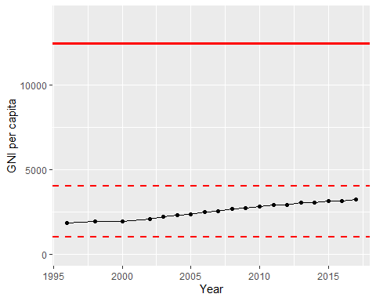

GNI Per Capita Trend